5.G.A
Graph points on the coordinate plane to solve real-world and mathematical problems.

1. Use the graph to answer the question. Which point is located at (1$\frac{1}{2}$, 1$\frac{1}{4}$ )?
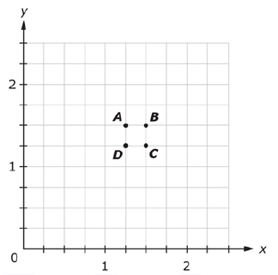
A. Point A
B. Point B
C. Point C
D. Point D

2. Plot each point on the coordinate plane.
Point A: Plot the point (2, 8).
Point B: Plot the point (4, 5).
Point C: Plot the point (7, 6).

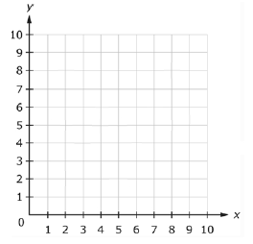
3. The graph shows the locations of Nina’s home, the park, her school, and the post office.
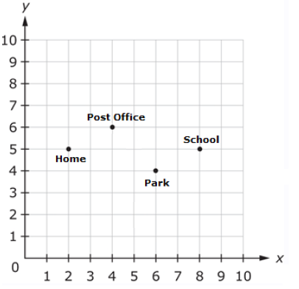
Write the coordinate pair that represents the location of each place.

Nina’s home: (_____, _____)

Post office: (_____, _____)

School: (_____, _____)

Park: (_____, _____)

4. The line graph below tracks the rain accumulation, measured every half hour, during a rainstrom that began at 2:00 p.m. and ended at 7:00 p.m. Use the information in the graph to answer the questions that follow.

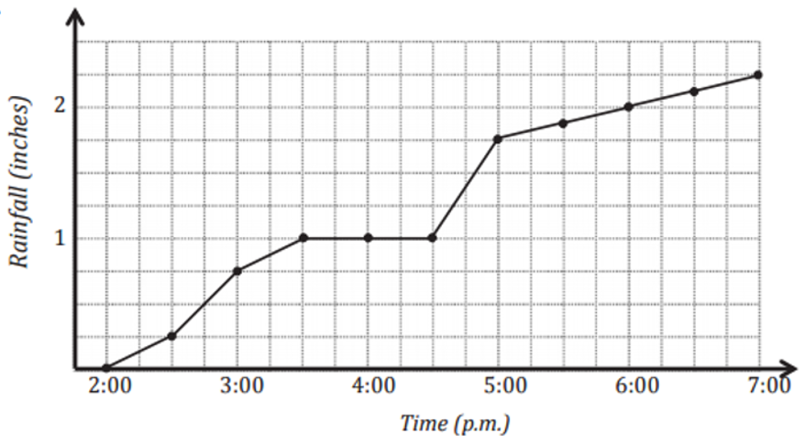

- How many inches of rain fell during this five-hour period?

- During which half-hour period did $\frac{1}{2}$ inch rain fall? Explain how you know.

- During which half-hour period did rain fall most rapidly? Explain how you know.

- Why do you think the line is horizontal between 3:30 p.m. and 4:30 p.m.?

- For every inch of rain that fell here, a nearby community ni the mountains received a foot and a half of snow. How many inches of snow fell in the mountain community between 5:00 p.m. and 7:00 p.m.?
Teacher Material
5.G.A
Reason about and solve one-variable equations and inequalities.
Question | Claim | Key/Suggested Rubric
1 | 1 | 1 point: Selects C
2¹ | 1 | 1 point:  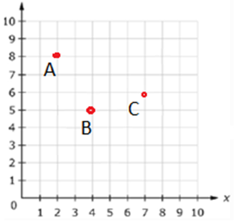
3¹ | 1 | 1 point:  Nina’s home: (2, 5)  Post office: (4, 6)  School: (8, 5)  Park: (6, 4)
4a | 2 | 1 point: 2.25 inches
4b² | 4 | 1 point: 2:30 – 3:00 p.m. At 2:30 pm. The rainfall total is 0.25 inches. At 3:00 p.m. the rainfall total is 0.75. The difference between these numbers is 0.50 inches.
4c² | 4 | 1 point: 4:30 – 5:00 p.m. From 4:30 p.m. to 5:00 p.m. it rains 0.75 inches in just that half hour. There is no other half hour on the chart that shows an increase this high in a half-hour period. That means it rains the hardest then.
4d² | 4 | 1 point: Since there is no increase in rainfall between these times, it means that it did not rain when there is a flat line on the graph.
4e² | 2 | 1 point: From 5:00 p.m. until 7:00 p.m. it rained 0.5 inches. Since 1 inch of rain produced 1.5 feet of snow, the ½ inch of rain would mean ¾ feet or 9 inches of snow in the mountains.

From Smarterbalanced.org. Grade 5, Claim 1, Target J Item Specifications. Internet. Available from http://www.smarterbalanced.org/smarter-balanced-assessments/; accessed 11/2015.
From EngageNY.org of the New York State Education Department. Grade 5 Mathematics Module 6, Topic D, Lesson 19. Internet. Available from https://www.engageny.org/resource/grade-5-mathematics-module-6-topic-d-lesson-19; accessed 11/2015.

