Statistics: Interpreting Data

1. Select the dot plot that represents the given test scores.  
     
   65, 45, 50, 85, 55, 85, 60, 70, 75, 55, 80, 85, 90, 75  
     
   A.The number line is labeled "Test Scores" and has a scale from 45 to 85 in intervals of 10. The following number of points are plotted: at 45, 1 point; at 50, 1 point; at 60, 1 point; at 65, 2 points; at 70, 1 point; at 75, 2 points; at 80, 2 points; at 85, 4 points, at 90, 1 point. B.The number line is labeled "Test Scores" and has a scale from 45 to 85 in intervals of 10. The following number of points are plotted: at 45, 1 point; at 50, 1 point; at 55, 2 points; at 60, 1 point; at 65, 1 point; at 70, 1 point; at 75, 2 points; at 80, 1 point; at 85, 3 points, at 90, 1 point.   
     
   C.The number line is labeled "Test Scores" and has a scale from 45 to 85 in intervals of 10. The following number of points are plotted: at 45, 1 point; at 50, 1 point; at 55, 1 point; at 60, 1 point; at 65, 2 points; at 70, 1 point; at 75, 2 points; at 80, 2 points; at 85, 4 points, at 90, 1 point. D.The number line is labeled "Test Scores" and has a scale from 45 to 85 in intervals of 10. The following number of points are plotted: at 45, 1 point; at 50, 1 point; at 60, 1 point; at 65, 1 point; at 70, 1 point; at 75, 1 point; at 80, 1 point; at 85, 1 point, at 90, 1 point.
2. Select the histogram that represents the given test scores.  
     
   47, 88, 59, 76, 61, 45, 65, 65, 80, 71, 76, 60, 81, 83, 85, 85, 92, 54  
     
   A.The histogram is titled "Histogram of Test Scores." The horizontal axis is labeled "Test Scores" and has a scale from 45 to 95 in increments of 10. The vertical scale is labeled "Frequency" and has a scale from 0 to 8 in increments of 2. The heights of the bars is: from 45 to 50, 2; from 60 to 65, 2; from 65 to 70, 2; from 70 to 75, 1; from 75 to 80, 2; from 80 to 85, 3; from 85 to 90, 3; from 90 to 95, 1. B.The histogram is titled "Histogram of Test Scores." The horizontal axis is labeled "Test Scores" and has a scale from 45 to 95 in increments of 10. The vertical scale is labeled "Frequency" and has a scale from 0 to 8 in increments of 2. The heights of the bars is: from 45 to 50, 2; from 60 to 65, 2; from 65 to 70, 2; from 70 to 75, 2; from 75 to 80, 2; from 80 to 85, 3; from 85 to 90, 3; from 90 to 95, 1.   
     
   C.The histogram is titled "Histogram of Test Scores." The horizontal axis is labeled "Test Scores" and has a scale from 45 to 95 in increments of 10. The vertical scale is labeled "Frequency" and has a scale from 0 to 8 in increments of 2. The heights of the bars is 1 for all increments: 45 to 50, 50 to 55, 55 to 60, 60 to 65, 65 to 70, 70 to 75, 75 to 80, 80 to 85, 85 to 90, and 90 to 95. D.The histogram is titled "Histogram of Test Scores." The horizontal axis is labeled "Test Scores" and has a scale from 45 to 95 in increments of 10. The vertical scale is labeled "Frequency" and has a scale from 0 to 8 in increments of 2. The heights of the bars is: from 45 to 50, 2; from 50 to 55, 1; from 55 to 60, 1; from 60 to 65, 2; from 65 to 70, 2; from 70 to 75, 1; from 75 to 80, 2; from 80 to 85, 3; from 85 to 90, 3; from 90 to 95, 1.
3. Select the box plot that represent the given test scores.  
     
   47, 91, 48, 69, 65, 66, 75, 89, 85, 71

A. The number line is labeled "Test Scores" and has a scale from 45 to 95 in intervals of 10. The minimum is approximately 47, the lower quartile is 65, the median is approximatley 77, the upper quartile is 85, and the maximum is approximately 91.   
  
B. The number line is labeled "Test Scores" and has a scale from 45 to 95 in intervals of 10. The minimum is approximately 47, the lower quartile is approximately 67, the median is approximatley 77, the upper quartile is approximately 84, and the maximum is approximately 91.   
  
C. The number line is labeled "Test Scores" and has a scale from 45 to 95 in intervals of 10. The minimum is approximately 47, the lower quartile is 65, the median is 70, the upper quartile is 85, and the maximum is approximately 91.   
  
D. The number line is labeled "Test Scores" and has a scale from 45 to 95 in intervals of 10. The minimum is approximately 47, the lower quartile is approximately 67, the median is approximatley 72, the upper quartile is approximately 84, and the maximum is approximately 91.

1. Create a histogram for the given test scores.  
     
   40, 45, 48, 50, 52, 58, 61, 63, 71, 73, 75, 75, 85, 87, 88, 90, 92, 93, 98, 100, 100  
     
   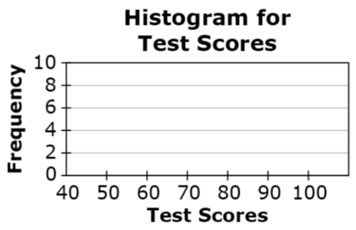
2. Data distributions are shown for the taste quality of a farm’s red apples at different points in time during the harvest season.  
     
   Two line graphs. The line graph on th left has the title "Apple Quality in Early May" with a horizontal axis labeled "Quality" and a vertical axis labeled "Number of Apples." There is no scale on either axes. The graph has a maximum near the left end of the graph with a tapper to the right. The line graph on th left has the title "Apple Quality in Late July" with a horizontal axis labeled "Quality" and a vertical axis labeled "Number of Apples." There is no scale on either axes. The graph has a maximum near the right end of the graph with a tapper to the left.   
     
   Which summary statistics would be best to use to compare the two data sets and why?  
     
   A. The median and the interquartile range because the data sets are normally distributed.  
   B. The mean and standard deviation because the data sets are normally distributed.   
   C. The median and the interquartile range because both data sets are skewed.  
   D. The mean and standard deviation because both data sets are skewed.
3. A used-car dealership has 27 cars for sale. The least expensive car costs $4499. The most expensive car costs $8399. The car priced at $4499 is then sold. Select whether the value for each statistic, for the prices of the cars, increases, decreases, or cannot be determined after the car is sold.

|  | **Increases** | **Decreases** | **Cannot Be Determined** |
| --- | --- | --- | --- |
| **Mean** |  |  |  |
| **Median** |  |  |  |
| **Standard Deviation** |  |  |  |

1. The scatterplot shows the weight and gas mileage for 31 cars.  
     
   A scatterplot. The title is "Car Mass vs. Gas Mileage." The horizontal axis is labeled "Mass (kilograms) and has a scale from 1000 to 2000 in increments of 250. The vertical axis is labeled "Mileage (Miles per gallon)" and has a scale from 10 to 30 in increments of 5. There are approximately 25 points plotted on the scatterplot, with all locations approxiate: (1100, 30), (1100, 27), 2 points near (1100, 28), (1250, 29), (1250, 27), (1300, 26), (1350, 21), (1375, 21), (1400, 17), (1425, 20), (1425, 21), (1450, 25), (1475, 22), (1525, 19), 2 points near (1530, 15), (1530, 13), (1550, 25), (1590, 24), (1590, 23), (1590, 20), (1650, 11), (1700, 13), (1725, 23), (1975, 23), (1975, 19).  
     
   **Part A**Draw a line of best fit on the scatterplot.  
     
   **Part B**What is the meaning of the slope of the line of best fit in terms of the situation?  
     
   A. For every additional kilogram of mass, the gas mileage is predicted to increase 0.013

miles per gallon.

B. For every additional kilogram of mass, the gas mileage is predicted to decrease 0.013

miles per gallon.

C. For every additional kilogram of mass, the gas mileage is predicted to increase 3 miles

per gallon.

D. For every additional kilogram of mass, the gas mileage is predicted to decrease 3 miles

per gallon.

1. Two airlines each made 30 flights. The dot plots shown compare how many minutes the actual arrival times were before or after the scheduled arrival times of these flights.  
     
   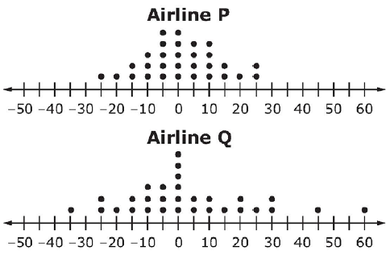

* Negative numbers represent the minutes the flight arrived before its scheduled time.
* Positive numbers represent the minutes the flight arrived after its scheduled time.
* Zero indicates the flight arrived on time.

Assuming you want to arrive as close to the scheduled time as possible, from which airline should you buy your ticket? Use concepts of center and/or spread of the data shown in the dot plots in your answer.

1. Lisa was throwing a dart at a target. She threw the dart 50 times with her left hand and 50 times with her right hand. The histograms show the distance Lisa **missed** the target by each time.  
     
   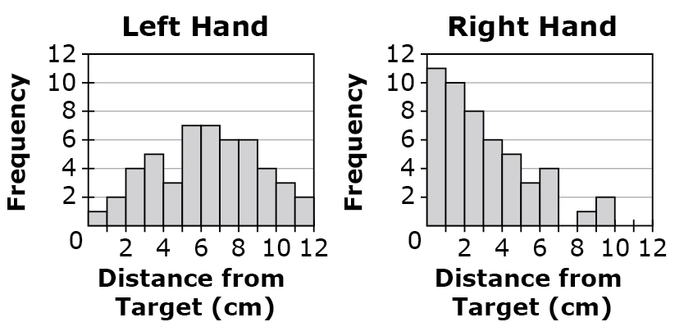  
     
   Which statement is an appropriate inference based on the median of each data set?

A. Lisa has better aim with her left hand because the median for her left hand is greater

than the median for her right hand.

B. Lisa has better aim with her right hand because the median for her left hand is greater

than the median for her right hand.

C. Lisa has better aim with her left hand because the median for her left hand is less than

the median for her right hand.

D. Lisa has better aim with her right hand because the median for her left hand is less than

the median for her right hand.

1. The distribution of heights of 1000 women and 1000 men selected at random from the population of a large metropolitan area are shown.

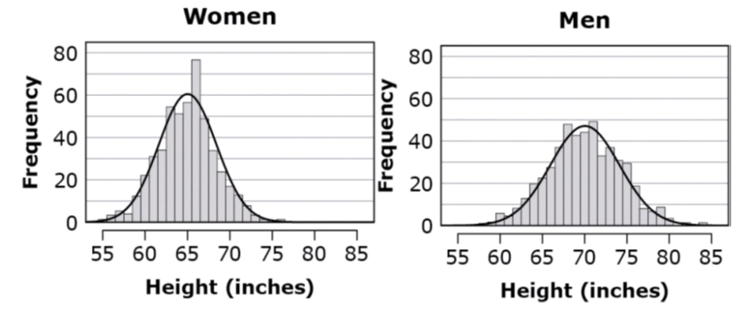

Which statement gives an accurate comparison of the heights of men and women shown?

A. The mean height for women is less than for men and women’s heights vary less than

men’s heights.

B. The mean height for women is less than for men and women’s heights vary more than

men’s heights.

C. The mean height for women is greater than for men and women’s heights vary less than

men’s heights.

D. The mean height for women is greater than for men and women’s heights vary more

than men’s heights.

**Teacher Material**

S-ID.A

Summarize, represent, and interpret data on a single count or measurement variable.

S-ID.B

Summarize, represent, and interpret data on two categorical and quantitative variables

S-ID.C

Interpret linear models

| **Question** | **Claim** | **Key/Suggested Rubric** |
| --- | --- | --- |
| 1[1] | 1 | **1 point:** Selects B. |
| 21 | 1 | **1 point:** Selects D. |
| 31 | 1 | **1 point:** Selects C. |
| 41 | 1 | **1 point:** A histogram. The title is "Histogram for Test Scores." The horizontal axis is labeled "Test Scores" and has a scale from 40 to 100 in increments of 10. The vertical axis is labed "Frequency" and has a scale from 0 to 10 in increments of 2. The height of the bars histogram is: from 40 to 50 is 3, from 50 to 60 is 3, from 60 to 70 is 2, from 70 to 80 is 4, from 80 to 90 is 3, from 90 to 100 is 4, and above 100 is 2. |
| 51 | 1 | **1 point:** Selects C |
| 61 | 1 | **1 point:**   |  | **Increases** | **Decreases** | **Cannot Be Determined** | | --- | --- | --- | --- | | **Mean** | x |  |  | | **Median** |  |  | x | | **Standard Deviation** |  | x |  | |
| 7[2] | 2 | **2 points:** Draws a line that fits the data (lines may vary; see **Example**) AND Selects B  **Example:** A scatterplot. The title is "Car Mass vs. Gas Mileage." The horizontal axis is labeled "Mass (kilograms) and has a scale from 1000 to 2000 in increments of 250. The vertical axis is labeled "Mileage (Miles per gallon)" and has a scale from 10 to 30 in increments of 5. There are approximately 25 points plotted on the scatterplot. A line is drawn from approximately (0, 28) to approximately (2000, 15). **1 point:** Draws a line that fits the data OR Selects B. NOTE: The slope of the line that fits the data should have a slope, *m*, such that –0.02 < *m* < –0.01. |
| 8[3] | 4 | **1 point**: Answers will vary. **Example:** I would choose Airline P because the range of the times is only 50 minutes, and for Airline Q the range of the times is 95 minutes. |
| 93 | 4 | **1 point:** Selects B |
| 103 | 4 | **1 point:** Selects A |

1. From Smarterbalanced.org. Grade 11, Claim 1, Target P Item Specifications. Internet. Available from <http://www.smarterbalanced.org/smarter-balanced-assessments/>; accessed 11/2015.
2. From Smarterbalanced.org. Grade 11, Claim 2 Item Specifications. Internet. Available from <http://www.smarterbalanced.org/smarter-balanced-assessments/>; accessed 11/2015.
3. From Smarterbalanced.org. Grade 11, Claim 2 Item Specifications. Internet. Available from <http://www.smarterbalanced.org/smarter-balanced-assessments/>; accessed 11/2015.