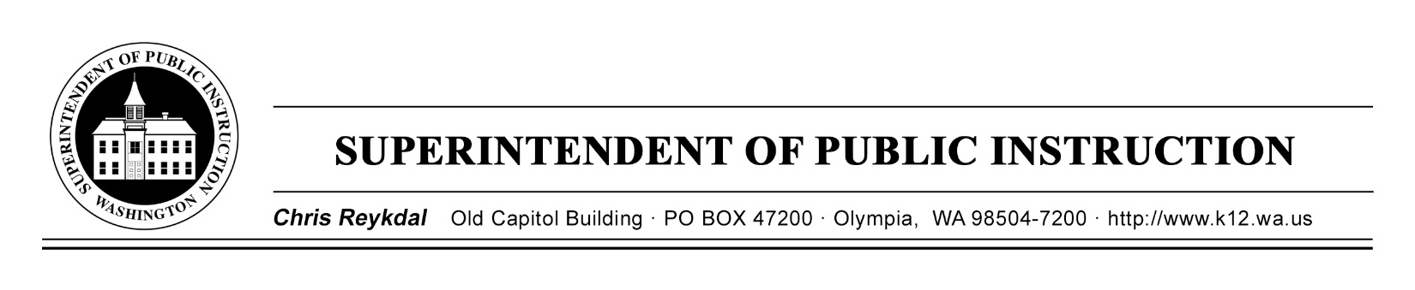
Dyslexia Advisory Council | March 4, 2019 | Sea -Tac Conference Center
Implementing E2SSB 6162
Time | Focus | Resources | Notes
8 AM | Sign In  Technology Check  Sign Up for Public Comment
8:30 AM | Welcome  Introductions  Map of the Day for the Morning | Agenda
 | Review Request for Qualification and Quotation | RFQQ
 | Timeline for Meeting RCW Expectations | Timeline
10:15 AM | Public Comment | Written Public Comments for Council
11 AM | Break
11:15 AM | Executive Session Commences
Executive Session
Map of the Day for Afternoon
Sign Conflict of Interest

11:45 AM | Executive Session  Working Lunch  Reimbursements  Review FAQ Handouts
12:15 PM | Executive Session  Reviewing Letters of Intent  Vendor Pre-Bid Conference  Developing Scoring Rubrics
2:15 PM | Break
2:30 PM | Executive Session  Continue Developing Scoring Rubrics
3:30 PM | Executive Session  Closing Out the Day  Feedback Form  Next Meeting
4 PM | Executive Session Concludes  Good-Bye and Safe Travels

