

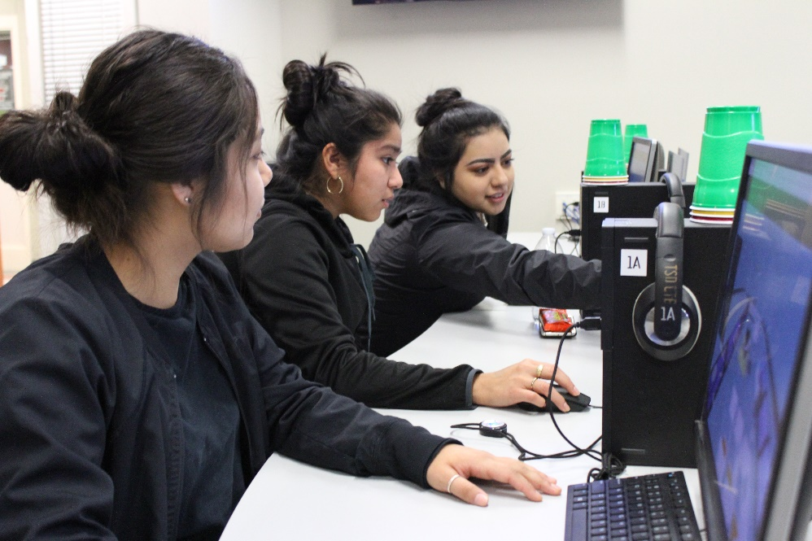**Educational Technology Learning Standards: Grades 9-12**

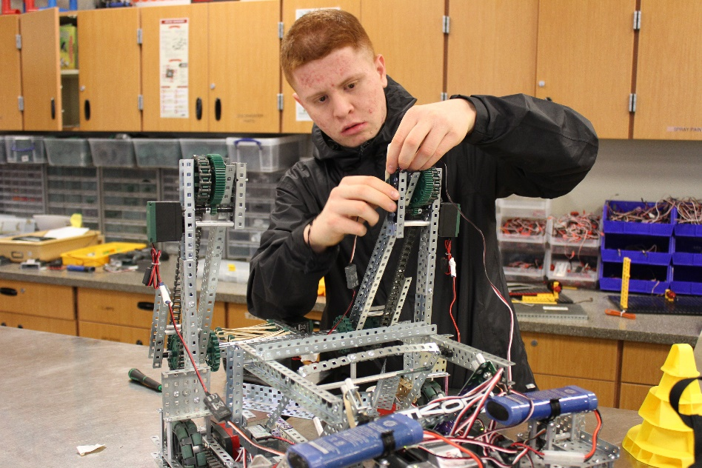

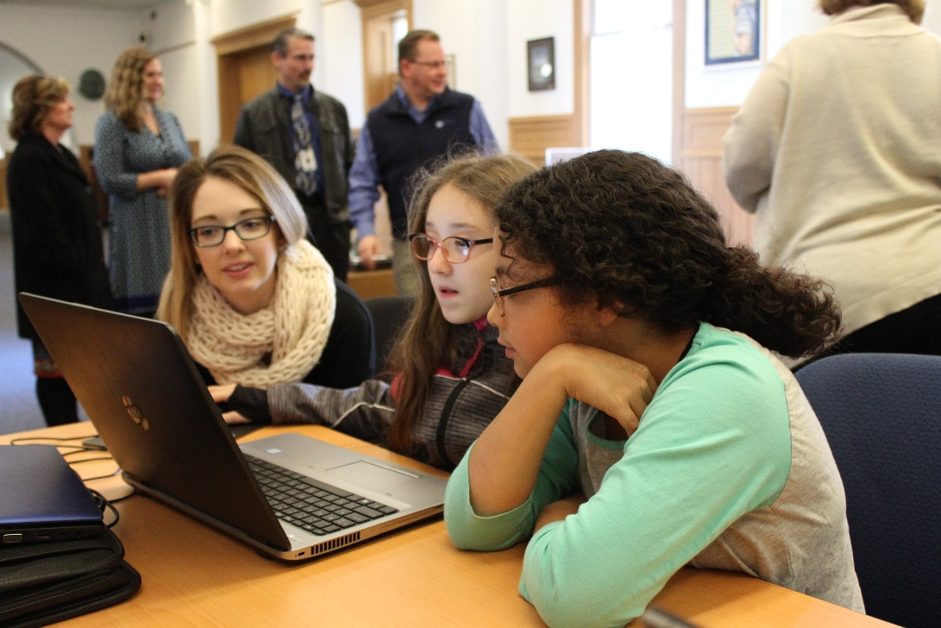

***Adopted May, 2018***

*****Photos: Toppenish High School, Sunnyside High School and OSPI, courtesy of OSPI***

# For complete K-12 Educational Technology Standards go to:

[*http://www.k12.wa.us/EdTech/Standards/default.aspx*](http://www.k12.wa.us/EdTech/Standards/default.aspx)

**Creative Commons Attribution-NonCommercial LIcense Logo (CC BY NC)
**

Except where otherwise noted, the Washington Educational Technology K–12 Learning Standards (<http://www.k12.wa.us/edtech/Standards>) by the Office of Superintendent of Public Instruction (<http://k12.wa.us/>) are licensed under a Creative Commons Attribution Non-Commercial 4.0 International License (<https://creativecommons.org/licenses/by-nc/4.0/>). All logos and trademarks are property of their respective owners.

Portions of this work are based on the 2016 International Society for Technology in Education (ISTE) Standards for Students (<https://www.iste.org/standards/for-students>)

ISTE Standards for Students, ©2016, ISTE (International Society for Technology in Education), iste.org. All rights reserved.

Standards referenced include:

*The College, Career, and Civic Life (C3) Framework for Social Studies State Standards: Guidance for Enhancing the Rigor of K-12 Civics, Economics, Geography, and History.* National Council for the Social Studies (NCSS),Silver Spring, MD, 2013, <https://www.socialstudies.org/c3>

*Common Core State Standards.* National Governors Association Center for Best Practices and Council of Chief State School Officers, Washington D.C., 2010, <http://www.corestandards.org>

*CSTA K-12 Computer Science Standards.* Computer Science Teachers Association*,* Albany, NY, 2017, <http://www.csteachers.org/page/standards>

Next Generation Science Standards: For States, By States.The National Academies Press, Washington D.C., 2013, <https://www.nextgenscience.org>

# 

# 2018 Standards for Technology Literate & Fluent Students

***(Based upon 2016 ISTE Student Standards)***

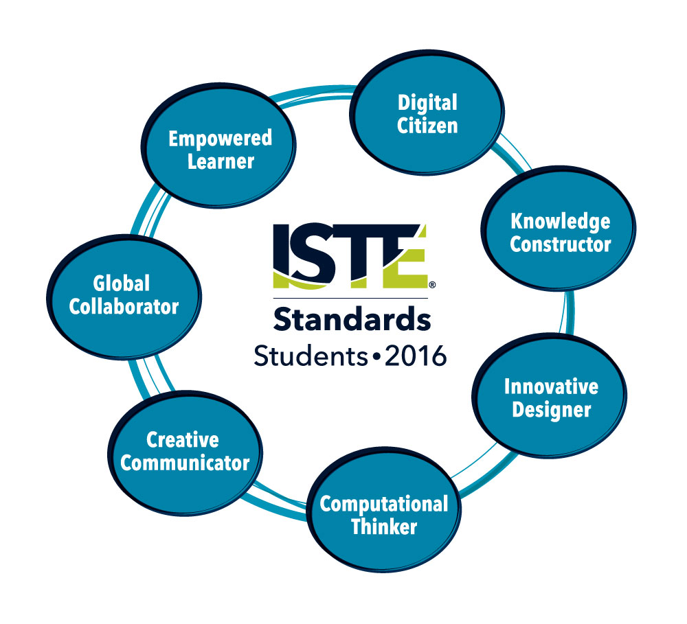

1. **Empowered Learner** - Students leverage technology to take an active role in choosing, achieving and demonstrating competency in their learning goals, informed by the learning sciences.

2. **Digital Citizen** - Students recognize the rights, responsibilities and opportunities of living, learning and working in an interconnected digital world, and they act and model in ways that are safe, legal and ethical.

3. **Knowledge Constructor** - Students critically curate a variety of resources using digital tools to construct knowledge, produce creative artifacts and make meaningful learning experiences for themselves and others.

4. **Innovative Designer** - Students use a variety of technologies within a design process to identify and solve problems by creating new, useful or imaginative solutions.

5. **Computational Thinker** - Students develop and employ strategies for understanding and solving problems in ways that leverage the power of technological methods to develop and test solutions.

6. **Creative Communicator** - Students communicate clearly and express themselves creatively for a variety of purposes using the platforms, tools, styles, formats and digital media appropriate to their goals.

7. **Global Collaborator** - Students use digital tools to broaden their perspectives and enrich their learning by collaborating with others and working effectively in teams locally and globally.

ISTE Standards•S © 2016 International Society for Technology in Education.

# Understanding the Educational Technology Standards Framework

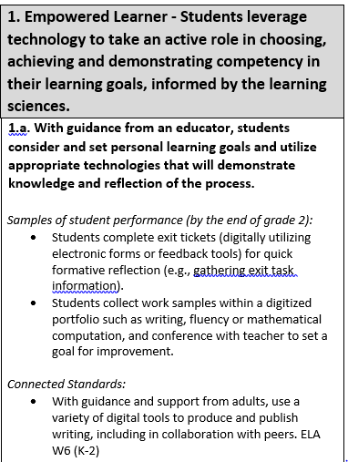

A **Standard**is a broad statement of the learning that applies to Grades K–12.

A **Performance Indicator** is a statement containing the essential content or process to be learned and the cognitive demand required to learn it. Each standard includes developmentally-appropriate grade-band performance indicators, which are considered essential to the standards.

**Samples of student performance** provide specific illustrations of the learning by the completion of the grade band. However, these examples are not exhaustive, and educators are encouraged to find multiple ways by which learners can demonstrate what they know.

**Connected standards** are logical connections to other content areas at approximately the same grade that also have a match in cognitive demand. With this alignment, teachers can expect that when students can demonstrate mastery of one standard (educational technology or other content area), they can also meet the other.

**Connected Standards Codes**

* C3= College, Career, and Civic Life (C3) Framework for Social Studies State Standards (<https://www.socialstudies.org/c3>)
* CS=Computer Science Learning Standards (<http://www.k12.wa.us/ComputerScience/>)
* H=Health Standards (<http://www.k12.wa.us/HealthFitness/Standards.aspx>)
* ELA=English Language Arts Standards (<http://www.corestandards.org/ELA-Literacy/>)
* Math=Mathematics Standards (<http://www.k12.wa.us/Mathematics/Standards.aspx>)
* PE=Physical Education Standards (<http://www.k12.wa.us/HealthFitness/Standards.aspx>)
* Science=Next-Generation Science Standards (<https://www.nextgenscience.org/get-to-know>)
* Social Studies=Social Studies Standards (<http://www.k12.wa.us/SocialStudies/EALRs-GLEs.aspx>)

# Grades 9-12 Standards for Technology Literate and Fluent Students

|  |  |
| --- | --- |
| **1. Empowered Learner - Students leverage technology to take an active role in choosing, achieving and demonstrating competency in their learning goals, informed by the learning sciences.** | |
| **1.a. Students articulate and set personal learning goals, develop strategies leveraging technology to achieve them and reflect on the learning process itself to improve learning outcomes.**  *Samples of student performance (by the end of grade 12):*   * Students create a digital portfolio that will provide the means to articulate and monitor their personal learning goals and G.P.A. (e.g., High School and Beyond Plan or Student-Led Conference). * Student use digital tools to create study guides, interactive notebooks, flashcards, etc. to help them meet personal learning goals.   *Connected Standards:*   * Implement strategies to achieve a personal health goal using technology to develop, monitor, and evaluate progress. H6.W7.HS * Design and implement a personal fitness and nutrition plan (assessment scores, goals for improvement, plan of activities for improvement, log of activities to reach goals, timeline for improvement). PE3.8.HS1 |
| **1.b. Students build networks and customize their learning environments in ways that support the learning process.**  *Samples of student performance (by the end of grade 12):*   * Students participate in school-approved online groups to support learning (e.g., online discussion boards through a Learning Management System). * Students collaboratively take notes in an online “master document” during class to be used by all to share questions, further explanation, comments, and constructivist learning. * Students curate a Personal Learning Network (PLN) for a specific curricular area or topic, using a variety of social media feeds, news sites, people, etc. to support critical thinking skills. * Students work collaboratively on an online/real-time team project to create one end-product (e.g., a science project presentation). Groups are required first to define and articulate the steps of their process, including the strengths and responsibilities of each member, and how each step is intended to enrich the quality of the end-product. |
| **1.c. Students use technology to seek feedback that informs and improves their practice and to demonstrate their learning in a variety of ways.**  *Samples of student performance (by the end of grade 12):*   * Students use technology to connect and learn from experts in their field of study. * Students interact and collaborate with others using a variety of digital tools (e.g. an LMS or social media site). * Students use online forms to gather feedback from peers after a final presentation, identifying areas where they wish to improve and fashioning survey questions whose answers will inform their development. * Students share a collaborative online tool to receive written or video (recorded or live) feedback from classmates, school audience, or an audience or expert outside of the school district.   *Connected Standards:*   * Use technology, including the Internet, to produce, publish, and update individual or shared writing products, taking advantage of technology's capacity to link to other information and to display information flexibly and dynamically. ELA W6 |
| **1.d. Students understand the fundamental concepts of technology operations, demonstrate the ability to choose, use and troubleshoot current technologies and are able to transfer their knowledge to explore emerging technologies.**  *Samples of student performance (by the end of grade 12):*   * Student create help documents, screencasts, and other digital artifacts to demonstrate how they solved their issue so others may benefit by reading or viewing. * Students analyze and evaluate the ease of use and effectiveness of available features of selected digital learning tools and resources. * Students report on the capacities and limitations of various technologies as a content exploration, recommending different technologies to peers for specific purposes. |

|  |  |
| --- | --- |
| **2: Digital Citizen - Students recognize the rights, responsibilities and opportunities of living, learning and working in an interconnected digital world, and they act and model in ways that are safe, legal and ethical.** | |
| **2.a. Students cultivate and manage their digital identity and reputation and are aware of the permanence of their actions in the digital world.**  *Samples of student performance (by the end of grade 12):*   * Students use a credible online identity review service to manage their reputation and design a PSA of the dos and don’ts when using the Internet. * Students analyze how social media impacts society, individuals and organizations. * Students actively cultivate a social media presence designed for future employers or schools to view.   *Connected Standards:*   * Compare how family, peers, culture, media, technology, and other factors influence safety and injury prevention practices and behaviors. H2.Sa1.HS |
| **2.b. Students engage in positive, safe, legal and ethical behavior when using technology, including social interactions online or when using networked devices.**  *Samples of student performance (by the end of grade 12):*   * Students research an incident reported by news media of unethical use of technology, ideally involving someone of their age, and identify steps that might have been taken to prevent or mitigate the incident as part of a class project. * Students participate and engage with the global community within expected norms of behavior and positive interaction. * Students can use advanced search tools and strategies to locate and then give credit for online images and other digital media.   *Connected Standards:*   * Analyze potential dangers of sharing personal information through electronic media. H1.Sa3.HS * Compare and contrast the influence of family, peers, culture, media, technology, and other factors on harassment, intimidation, and bullying. H2.So5.HS |

|  |
| --- |
| **2.c. Students demonstrate an understanding of and respect for the rights and obligations of using and sharing intellectual property.**  *Samples of student performance (by the end of grade 12):*   * Students practice ethical and appropriate use of all media and comply with copyright law. * Students cite electronic and print sources in appropriate format for school and personal work. * Students understand Fair Use and utilize Creative Commons Licensing for personal work to protect created digital products. |
| **2.d. Students manage their personal data to maintain digital privacy and security and are aware of data-collection technology used to track their navigation online.**  *Samples of student performance (by the end of grade 12):*   * Students practice safe and responsible sharing of information, data and opinions online. * Students understand privacy issues and how personal data is archived and publicly available. * Students understand how to actively manage their settings (e.g., purge cookies) to protect personal information.   *Connected Standards:*   * Explain the privacy concerns related to the collection and generation of data through automated processes that may not be evident to users. CS 3A-IC-29 |

|  |  |
| --- | --- |
| **3. Knowledge Constructor - Students critically curate a variety of resources using digital tools to construct knowledge, produce creative artifacts and make meaningful learning experiences for themselves and others.** | |
| **3.a. Students plan and employ effective research strategies to locate information and other resources for their intellectual or creative pursuits.**  *Samples of student performance (by the end of grade 12):*   * Students apply keyword choice search techniques (e.g., basic and advanced Boolean). * Students compare search browsers and recognize features that allow for filtering of information. * Students identify sources using a database to research material for a persuasive speech. * Students can modify search strategies to demonstrate resiliency in the research process.   *Connected Standards:*   * Create a resource that outlines where and how students can access valid and reliable health information, products, and services. H3.W4.HS * Gather relevant information from multiple authoritative print and digital sources, using advanced searches effectively; assess the usefulness of each source in answering the research question; integrate information into the text selectively to maintain the flow of ideas, avoiding plagiarism and following a standard format for citation. ELA W8 (9-10) * Gather relevant information from multiple authoritative print and digital sources, using advanced searches effectively; assess the strengths and limitations of each source in terms of the task, purpose, and audience; integrate information into the text selectively to maintain the flow of ideas, avoiding plagiarism and overreliance on any one source and following a standard format for citation. ELA W8 (11-12) * Gather relevant information from multiple sources representing a wide range of views while using the origin, authority, structure, context, and corroborative value of the sources to guide the selection. C3 D3.1 (9-12) * Creates and uses research questions that are tied to an essential question to focus inquiry on an idea, issue, or event. Social Studies 5.2.1 (9-10) |

|  |
| --- |
| **3.b. Students evaluate the accuracy, perspective, credibility and relevance of information, media, data or other resources.**  *Samples of student performance (by the end of grade 12):*   * Students compare and contrast information found about the same global issue from different databases and analyze bias and fairness to the topic, using advanced search tools and country codes to find sources originating from different countries. * Students use a framework for evaluating information found online. * Student recognize bias in online research and sources. * Students assess how point of view and purpose impact content, message, and style of text, media, digital, and online presentation.   *Connected Standards:*   * Evaluate how culture, media, society, and other people influence our perceptions about relationships and other related topics. H2.Se3.HS * Evaluate the credibility of a source by examining how experts value the source. C3 D3.2 (9-12) * Evaluates the validity, reliability, and credibility of sources when researching an issue or event. Social Studies 5.2.2 (9-10) |
| **3.c. Students curate information from digital resources using a variety of tools and methods to create collections of artifacts that demonstrate meaningful connections or conclusions.**  *Samples of student performance (by the end of grade 12):*   * Students collect information and report on an issue of their choice, creating a digital product that effectively highlights the reasoning behind their collection’s choice of media. * Students use online content curation tools to organize research and information, and personalize online news content. * Students analyze survey data, report information and display the data in a variety of ways to support conclusions. * Students create their own digital text/resource sets to show varying perspectives on an issue to support papers, presentations and other school projects that show their ability to make connections and evaluations of those varying sources.   *Connected Standards:*   * Evaluate resources for accessing valid and reliable information, products, and services for healthy eating. H3.N1.HS * Identify evidence that draws information directly and substantively from multiple sources to detect inconsistencies in evidence in order to revise or strengthen claims. C3 D3.3 (9-12) |
| **3.d. Students build knowledge by actively exploring real-world issues and problems, developing ideas and theories and pursuing answers and solutions.**  *Samples of student performance (by the end of grade 12):*   * Students explore a variety of media for current issues and then share their ideas for how to remediate those issues in a variety of formats (e.g., speech, debate, presentation). * Students examine various organizations that address a global issue and compare those solutions to their own ideas. * Students use statistics and other forms of data to inform their ideas on solutions to problems that have a global connection.   *Connected Standards:*   * Design, evaluate, and/or refine a solution to a complex real-world problem, based on scientific knowledge, student-generated sources of evidence, prioritized criteria, and tradeoff considerations. Science SEP 6 |

|  |  |
| --- | --- |
| **4. Innovative Designer - Students use a variety of technologies within a design process to identify and solve problems by creating new, useful or imaginative solutions.** | |
| **4.a. Students know and use a deliberate design process for generating ideas, testing theories, creating innovative artifacts or solving authentic problems.**  *Samples of student performance (by the end of grade 12):*   * Students implement, document and present the design process as applied to a particular product, process or problem.   *Connected Standards:*   * Using one or more technologies, design, monitor, and adjust a personal nutrition plan, considering cost, availability, access, nutritional value, balance, freshness, and culture. H7.N6.HS * Make a quantitative and/or qualitative claim regarding the relationship between dependent and independent variables. Science SEP 6 * Design a test of a model to ascertain its reliability. Science SEP 2 * Develop, revise, and/or use a model based on evidence to illustrate and/or predict the relationships between systems or between components of a system. Science SEP 2 * Develop and/or use multiple types of models to provide mechanistic accounts and/or predict phenomena, and move flexibly between model types based on merits and limitations. Science SEP 2 * Develop a complex model that allows for manipulation and testing of a proposed process or system. Science SEP 2 * Develop and/or use a model (including mathematical and computational) to generate data to support explanations, predict phenomena, analyze systems, and/or solve problems. Science SEP 2 * Plan an investigation or test a design individually and collaboratively to produce data to serve as the basis for evidence as part of building and revising models, supporting explanations for phenomena, or testing solutions to problems. Consider possible confounding variables or effects and evaluate the investigation’s design to ensure variables are controlled. Science SEP 3 * Plan and conduct an investigation individually and collaboratively to produce data to serve as the basis for evidence, and in the design decide on types, how much, and accuracy of data needed to produce reliable measurements and consider limitations on the precision of the data (e.g., number of trials, cost, risk, time), and refine the design accordingly. Science SEP 3 * Manipulate variables and collect data about a complex model of a proposed process or system to identify failure points or improve performance relative to criteria for success or other variables. Science SEP 3 |
| **4.b. Students select and use digital tools to plan and manage a design process that considers design constraints and calculated risks.**  *Samples of student performance (by the end of grade 12):*   * Students create a webpage to promote their school’s spring dramatic production, incorporating elements of line, shape, form, value, space, color, texture, graphics and typography, and principles of organization of balance and proportion, that demonstrate design constraints and calculated risks.   *Connected Standards:*   * Develop and/or use a model (including mathematical and computational) to generate data to support explanations, predict phenomena, analyze systems, and/or solve problems. Science SEP 2 * Select appropriate tools to collect, record, analyze, and evaluate data. Science SEP 3 * Design, evaluate, and/or refine a solution to a complex real-world problem, based on scientific knowledge, student-generated sources of evidence, prioritized criteria, and tradeoff considerations. Science SEP 6 * Use digital tools (e.g., computers) to analyze very large data sets for patterns and trends. Science SEP 4 |

|  |
| --- |
| **4.c. Students develop, test and refine prototypes as part of a cyclical design process.**  *Samples of student performance (by the end of grade 12):*   * Students evaluate a design solution using conceptual, physical, digital and mathematical models at various intervals of the design process in order to check for proper design and note areas where improvements are needed (e.g., check the design solutions against criteria and constraints).   *Connected Standards:*   * Plan an investigation or test a design individually and collaboratively to produce data to serve as the basis for evidence as part of building and revising models, supporting explanations for phenomena, or testing solutions to problems. Consider possible confounding variables or effects and evaluate the investigation’s design to ensure variables are controlled. Science SEP 3 * Plan and conduct an investigation individually and collaboratively to produce data to serve as the basis for evidence, and in the design decide on types, how much, and accuracy of data needed to produce reliable measurements and consider limitations on the precision of the data (e.g., number of trials, cost, risk, time), and refine the design accordingly. Science SEP 3 * Manipulate variables and collect data about a complex model of a proposed process or system to identify failure points or improve performance relative to criteria for success or other variables. Science SEP 3 * Design, evaluate, and/or refine a solution to a complex real-world problem, based on scientific knowledge, student-generated sources of evidence, prioritized criteria, and tradeoff considerations. Science SEP 6 * Design and iteratively develop computational artifacts for practical intent, personal expression, or to address a societal issue by using events to initiate instructions. CS 3A-AP-16 |
| **4.d. Students exhibit a tolerance for ambiguity, perseverance and the capacity to work with open-ended problems.**  *Samples of student performance (by the end of grade 12):*   * Students critically evaluate and demonstrate a design solution at multiple points of the design process, and consider design requirements and adjust processes and outcomes as needed. |

|  |  |
| --- | --- |
| **5. Computational Thinker - Students develop and employ strategies for understanding and solving problems in ways that leverage the power of technological methods to develop and test solutions.** | |
| **5.a. Students formulate problem definitions suited for technology-assisted methods such as data analysis, abstract models and algorithmic thinking in exploring and finding solutions.**  *Samples of student performance (by the end of grade 12):*   * Students are presented with civic problems, such as transportation or housing, and challenged to design and prototype technology-based solutions.   *Connected Standards:*   * Use mathematical, computational, and/or algorithmic representations of phenomena or design solutions to describe and/or support claims and/or explanations. Science SEP 5 |
| **5.b. Students collect data or identify relevant data sets, use digital tools to analyze them, and represent data in various ways to facilitate problem-solving and decision-making.**  *Samples of student performance (by the end of grade 12):*   * Students construct a spreadsheet workbook with multiple worksheets, organize multiple worksheets to reflect the data, and use mathematical or logical functions, charts and data from all worksheets to convey the results. * Students collect and analyze data through the use of online survey tools. * Students download a large set of data and perform filtering and formula-based calculations in a spreadsheet to draw conclusions.   *Connected Standards:*   * Analyze data using tools, technologies, and/or models (e.g., computational, mathematical) in order to make valid and reliable scientific claims or determine an optimal design solution. Science SEP 4 |
| **5.c. Students break problems into component parts, extract key information, and develop descriptive models to understand complex systems or facilitate problem-solving.**  *Samples of student performance (by the end of grade 12):*   * Students create musical instruments using inexpensive microcontrollers, sensors, and sound-production components. * Students develop an instructional video, brochure, notebook, or other presentation tool to explain a complex scientific issue into smaller factors and systems to teach others about the issue.   *Connected Standards:*   * Create and/or revise a computational model or simulation of a phenomenon, designed device, process, or system. Science SEP 5 * Design, evaluate, and/or refine a solution to a complex real-world problem, based on scientific knowledge, student-generated sources of evidence, prioritized criteria, and tradeoff considerations. Science SEP 6 * Identify evidence that draws information directly and substantively from multiple sources to detect inconsistencies in evidence in order to revise or strengthen claims. C3 D3.3 (9-12) |
| **5.d. Students understand how automation works and use algorithmic thinking to develop a sequence of steps to create and test automated solutions.**  *Samples of student performance (by the end of grade 12):*   * Students apply techniques of algebra and functions to digitally represent and solve scientific and engineering problems. * Students apply systems thinking to solve a complex problem. |

|  |  |
| --- | --- |
| **6. Creative Communicator** - **Students communicate clearly and express themselves creatively for a variety of purposes using the platforms, tools, styles, formats and digital media appropriate to their goals.** | |
| **6.a. Students choose the appropriate platforms and tools for meeting the desired objectives of their creation or communication.**  *Samples of student performance (by the end of grade 12):*   * Students use digital learning tools and resources to identify communication needs considering goals, audience, content, access to tools or devices, timing of communication (e.g., time zones), etc.   *Connected Standards:*   * Communicate scientific and/or technical information or ideas (e.g. about phenomena and/or the process of development and the design and performance of a proposed process or system) in multiple formats (i.e., orally, graphically, textually, mathematically). Science SEP 8 * Present adaptations of arguments and explanations that feature evocative ideas and perspectives on issues and topics to reach a range of audiences and venues outside the classroom using print and oral technologies (e.g., posters, essays, letters, debates, speeches, reports, and maps) and digital technologies (e.g., Internet, social media, and digital documentary). C3 D4.3 (9-12) |
| **6.b. Students create original works or responsibly repurpose or remix digital resources into new creations.**  *Samples of student performance (by the end of grade 12):*   * Students research a current topic and select online information that is appropriate and credible to support a point of view, explaining why their audience should lend credence to their sources. * Students are able to use multiple creation programs to design a final product (e.g., composing music for a film, retouching images for a final product, etc.). |

|  |
| --- |
| **6.c. Students communicate complex ideas clearly and effectively by creating or using a variety of digital objects such as visualizations, models or simulations.**  *Samples of student performance (by the end of grade 12):*   * Students design models using a computer programming language to support ideas on a topic. * Students use graphic design software to create visual representations of a complex idea in a subject area.   *Connected Standards:*   * Develop a complex model that allows for manipulation and testing of a proposed process or system. Science SEP 2 * Present adaptations of arguments and explanations that feature evocative ideas and perspectives on issues and topics to reach a range of audiences and venues outside the classroom using print and oral technologies (e.g., posters, essays, letters, debates, speeches, reports, and maps) and digital technologies (e.g., Internet, social media, and digital documentary). C3 D4.3 (9-12) |
| **6.d. Students publish or present content that customizes the message and medium for their intended audiences.**  *Samples of student performance (by the end of grade 12):*   * Students engage local experts in final digital presentations, especially in a judging or evaluative context. * Student project planning exercises include an analysis of the target audience and how that audience best receives or interprets information.   *Connected Standards:*   * Design a drug-free message for a community beyond school. H8.Su3.HS |

|  |  |
| --- | --- |
| **7. Global Collaborator - Students use digital tools to broaden their perspectives and enrich their learning by collaborating with others and working effectively in teams locally and globally.** | |
| **7.a. Students use digital tools to connect with learners from a variety of backgrounds and cultures, engaging with them in ways that broaden mutual understanding and learning.**  *Samples of student performance (by the end of grade 12):*   * Students contribute to an online project that combines photos and personal stories in order to share perspectives and understanding. * Students connect with students and classrooms around the world using online tools. |
| **7.b. Students use collaborative technologies to work with others, including peers, experts or community members, to examine issues and problems from multiple viewpoints.**  *Samples of student performance (by the end of grade 12):*   * Students partner with students in other countries to collectively create software addressing a common global problem. * Students use recording media to take oral histories from community members and compile them into a representative data bank. * Students participate on online discussions about topics that encourage multiple perspectives on an issue. |
| **7.c. Students contribute constructively to project teams, assuming various roles and responsibilities to work effectively toward a common goal.**  *Samples of student performance (by the end of grade 12):*   * Students use project management tools to organize individual and group tasks and reflect on participation and goal completion. * Student project planning includes culturally responsive explorations, such as reporting on different cultures’ uses of technology. |
| **7.d. Students explore local and global issues and use collaborative technologies to work with others to investigate solutions.**  *Samples of student performance (by the end of grade 12):*   * Students connect with local health organizations to create digital promotional materials. * Students create collaborative presentations or websites that focus on solutions for a particular issue (e.g., a website with information and resources about climate change).   *Connected Standards:*   * Using collaborative technologies, design a message that promotes health for a community beyond school. H8.Su3.HS |

# Glossary

**Acceptable/Responsible Use Policy (AUP/RUP):** A school or organization’s official policy statement regarding the use of the Internet or other computer networks.

**Algorithm**: A process or set of steps to be followed in calculations or other problem-solving operations, especially by a computer.

**Authentic Problem:**

A genuine, real or original problem to be solved.

**Blogging:** The process of writing a blog (also known as a Weblog), an online journal in which the writer shares their thoughts about a particular subject with readers.

**Cloud computing:** The practice of storing and accessing data and programs over the Internet rather than a local server or a personal computer (e.g., iCloud, Google Cloud, OneDrive and Dropbox).

**Cookie**: A piece of code or data created by a web server and stored on a user's computer. It is used to keep track of the user's usage patterns and preferences.

**Creative Commons:** Creative Commons licenses are designed to facilitate and encourage more versatility and flexibility in copyright law.

**Cybersecurity:** Measures taken to protect networks, computers, programs and data from attack, damage or unauthorized access**.**

**Design Process**: An approach for breaking down a large project into manageable chunks.

**Digital Footprint**: The information about a particular person that exists on the Internet as a result of their online activity A digital identity is an online or networked identityadopted or claimed in cyberspace by an individual, organization or electronic device.

**Digital Portfolio:**  A collection of electronic evidence assembled and managed by a user. Also known as an e-portfolio or an electronic portfolio.

**Digital Stories:** A variety of forms of digital narratives (web-based stories, interactive stories, hypertexts and narrative computer games).

**Digital Tools:** Hardware and software that generate, store and process data.

**Ebook**: An electronic version of a printed book that can be read on a computer or handheld device designed specifically for this purpose.

**Encryption**: The process of converting electronic data to an unrecognizable or encrypted form, one that cannot be easily understood by unauthorized parties.

**Infographic:** A visual image such as a chart or diagram used to represent complex information or data quickly and clearly.

**Learning Management System (LMS):** A software application or Web-based technology used to plan, implement, and assess a specific learning process. Typically, an LMS provides an instructor with a way to create and deliver content, monitor student participation, and assess student performance.

**Makerspace:** A makerspace is a place where students can gather to create, invent, tinker, explore and discover using a variety of tools and materials.

**Malware:** The broad term to describe any malicious software designed by hackers. Malware includes viruses, worms, spyware, trojans, keyloggers, zombie programs and any other software that seeks to do one of four things: vandalize your computer in some way; steal your private information; take remote control of your computer (zombie your computer) for other ends; or manipulate you into purchasing something.

**Microcontroller:** A compact integrated circuit which is dedicated to perform one task and execute one specific application. A typical microcontroller includes a processor, memory and input/output peripherals on a single chip.

**Multimedia:** Digital products that integrate interactive text, images, sound and color. Multimedia can be anything from a simple PowerPoint slide show to a complex interactive simulation.

**Network:** A collection of computers that are linked together for the purpose of sharing information.

**Podcast:** A media file that is distributed over the Internet using syndication feeds, for playback on portable media players and personal computers.

**Pop-ups:** A secondary web browser window of varying size, often containing a form of advertising, which opens outside of the primary web browser window.

**Social Media**: The broad term for any online tool that enables users to interact with thousands of other users (e.g., Facebook, Twitter, LinkedIn, Google+, Instagram, Pinterest, Snapchat, Tumblr and Reddit).

**Virtual Field Trip:** A guided exploration through the World Wide Web that organizes a collection of pre-screened, thematically based web pages into a structured online learning experience.

**Virus:** A piece of programming code inserted into other programming to cause damage. Viruses can be sent in many forms but are often transmitted via email messages that, when opened, may erase data or cause damage to your hard disk. Some viruses are able to enter your email system and send themselves to other people in your list of contacts.

# References

Bailey, Gerald and Mike Ribble. *Digital Citizenship in Schools*. International Society for Technology in Education (ISTE), 2007.

The Center for Universal Design in Education, DO-IT Program, University of Washington, 2018, [www.washington.edu/doit/programs/center-universal-design-education/overview](http://www.washington.edu/doit/programs/center-universal-design-education/overview).

[*Culturally Responsive Teaching: A Guide to Evidence-based Practices for Teaching All Students Equitably*](http://educationnorthwest.org/resources/culturally-responsive-teaching-guide-evidence-based-practices-teaching-all-students). Region X Equity Assistance Center (EAC) at Education Northwest, 2016, [educationnorthwest.org/sites/default/files/resources/culturally-responsive-teaching-508.pdf](http://educationnorthwest.org/sites/default/files/resources/culturally-responsive-teaching-508.pdf).

*ISTE Standards for Students*. International Society for Technology in Education (ISTE), 2016,

[www.iste.org/standards/for-students](http://www.iste.org/standards/for-students)

[*Preparing Teachers for Schools as They Are:*](https://www.google.com/url?q=http://www.k12.wa.us/Compensation/pubdocs/PreparingTeachersforSchoolsAsTheyAre1.PDF&sa=U&ved=0ahUKEwj-gYXGyYPZAhUB62MKHcszAgEQFggFMAA&client=internal-uds-cse&cx=011492945478748372637:4tjnntgeczs&usg=AOvVaw3dyqtdSxAjkPqT7RlreJ6W) *Recommendations for Cultural Competence for all Teachers in Washington State*. Cultural Competency Work Group to the Professional Educator Standards Board, 2009,[drive.google.com/file/d/0BzB1kJv-8a4iN2pzZUlYVnJVOWM/view](https://drive.google.com/file/d/0BzB1kJv-8a4iN2pzZUlYVnJVOWM/view)

*Standards for the 21st Century Learner.* American Association of School Librarians (AASL),

American Library Association, 2008.

*What is Universal Design for Learning?* Center for Applied Special Technology (CAST), 2017,

[www.udlcenter.org/aboutudl/whatisudl](http://www.udlcenter.org/aboutudl/whatisudl)