LISTING OF SPECIAL INSPECTIONS & TESTINGS

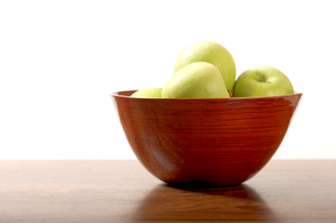
G O L D E N D E L I C I O U S & A S S O C I A T E S

April 1, 20xx

Red Apple Elementary Replacement (N/L) and Modernization project

Proposed Special Inspections and Testings
- Soils Compaction and Inspections
- Structural Cast-in-Place Concrete
- All Structural Steel Fabrications
- Mechanical and Electrical Work

Estimated fee for independent inspections and testing: New - $2,500
Mod - $12,500

1234 Crispy Crescent Rd., San Gala, WA 99998
T : 509.555.1515 F : 509.555.1518 E : mail@goldendelicious architect.net

