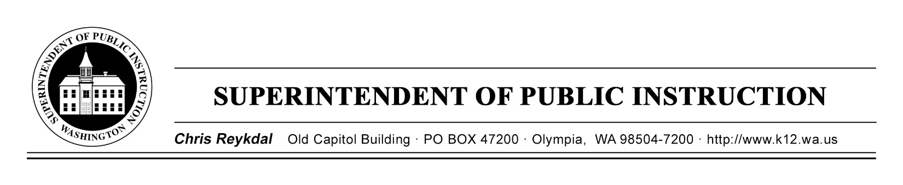

Salary Grid Workgroup

Puget Sound ESD
800 Oakesdale Avenue SW
Renton, WA 98057

October 30, 2017
1-4pm

1:00-1:30 Introductions, agenda and plan overview, norms and decision making protocol

1:30-2:00 Review salary grid workgroup purpose in ESSB 2242 and previous compensation policy recommendations
Maria Flores

2:00-2:30 Review salary grid survey results
Maria Flores

2:30-2:45 Basic mathematical salary grid
T.J. Kelley and Lisa Dawn-Fisher

2:45-3:50 Salary grid options proposed by members and discussion
Maria Flores

3:50-4:00 Final announcements and closing

